How has Bo Ai School affected the community around it
During the Easter Mission Trip to the Bo Ai School in March 2013, other than the contingent of about 60 volunteers from Hong Kong, there were about 8 volunteers from Beijing led by Juliana Wang, one of the directors of Bo Ai Foundation (“BAF”) based in Beijing. While all the volunteers were busy helping out in the dental or medical clinic, cooking and teaching, some of those from Beijing were seldom seen or heard. Among them were Kenneth Ku and Richard Tin.
It was not until our last night at the School that I got to meet Kenneth and Richard. It turned out that Kenneth and Richard had been secretly interviewing students, parents, staff and the villagers to find out how the Bo Ai School had affected the community there.
Kenneth had heard a lot of wonder stories about the Bo Ai School and the good work of Christine Chan from Juliana but he had his doubts. This year he decided to come and investigate to find out for himself what Bo Ai School was all about.
Kenneth and Richard presented their findings to the directors of BAF. It is fair to say that the findings were astounding. This is a summary of their findings :-
- There were more people getting married in the nearby villages – Apparently this was because they felt that the area was served by an excellent elementary school, the Bo Ai School. The phenomenum is similar to many developed countries where parents tend to move into school areas which have the best schools. The people had such high regard for the Bo Ai School that they wanted to get married and have a child so that the child could receive a good education from the Bo Ai School.
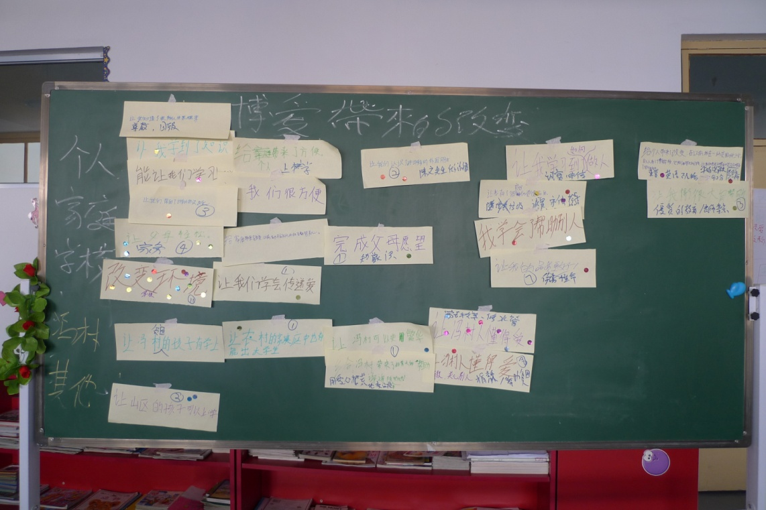
- The students have learnt to take care of themselves. They acquired good habits and civil behaviour and passed what they learnt to their families. They learnt how to be thankful for what they have and to spread love to others. Some of the villagers said that they could easily tell that a child is a Bo Ai student from the way they behaved. When a Bo Ai student bought snacks sold on a stick in the street, they would not throw the stick on the street after finishing the snacks but would keep it and discard it in a rubbish bin. They also exhibited much better manners.
- Young teachers who came to the School as young graduates found that they had learnt a lot and improved themselves after starting work at the School. They enjoyed their work in the School and said that working at Bo Ai had ignited their passion for teaching. While they came to Bo Ai for a job, now they find themselves greatly attached to it.
- Parents learnt about the virtue of honesty. There was an incident where a parent picked up a wallet on the street containing about 3,000 Yuan, which is a lot of money in this part of China. When the parent took the wallet home, his child told his parent that he must bring it to the authorities as it was not right to take things that did not belong to them. They brought the wallet back to the School and the wallet was returned to the rightful owner.
- Parents also said that their homes had become cleaner and they stopped swearing at home. They were very happy with the way that the School was being managed.
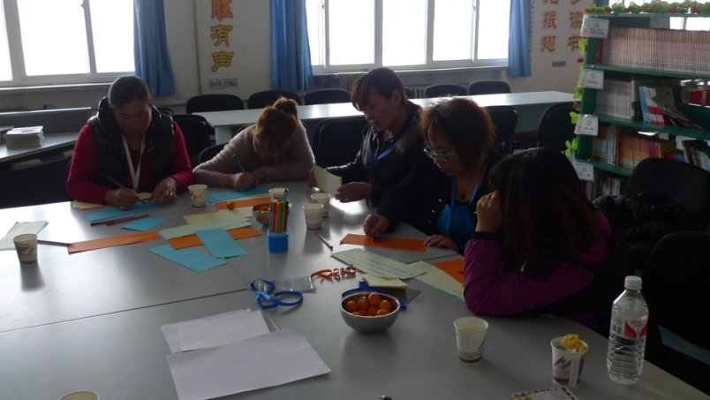
- The teachers and staff of the School place a lot of emphasis on team spirit in their work. They maintain close contact with the students’ parents and families. In managing the students’ performance, an approach of encouragement is used rather than punishment.
- The villagers around the School said that the villages had become cleaner. Libraries were set up and the spirit of learning became stronger. Feng Cun馮村(the village right next to the School) had become more prosperous. They said these were all brought about by the School. Other schools were looking to Bo Ai School as their model.
We all know that the open exam results of Bo Ai students have consistently placed Bo Ai School among the top schools in Shanxi Province. The advancement in academic achievement can be easily measured. The average score of the School’s students at the start of its operation was in the 30’s. At the end of the academic year, the average score shot to over 90 and this has been maintained throughout the past years. However, Bo Ai School is not just about academic excellence. Its aim is to spread love among the community and provide a holistic education to the students without regard to their means or social background so that they will become model citizens in the modern world, citizens who respect and love others and citizens who are alert to their duties as responsible members of society.
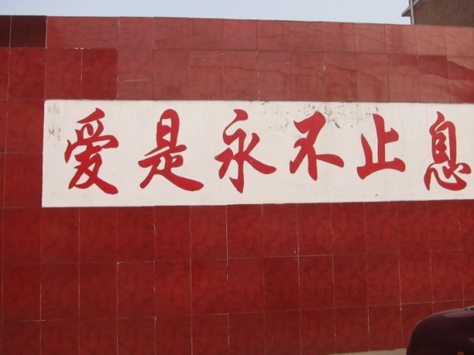
Before Kenneth’s study, we did not know whether and how Bo Ai had achieved its aims other than academic excellence. Now, we have the answer through Kenneth’s efforts. The study shows that not only have the students been learning well on how to be model citizens, they have also spread what they learnt from the School to their families and friends. The Bo Ai School has affected the community around it in a significant way. The change brought about by the School in the people’s approach to learning, their values and behaviour and even culture within the nearby communities is most remarkable. The motto of the School is “Never Ending Love愛是永不止息”. This love is thriving in this small School in Shanxi and has spilled over to the community around it.
The directors of BAF had always known that the School was doing a great job but even they did not realize how much the School has contributed to the overall improvement to the civil standards of the surrounding communities. The study is the first of its kind and stands testimony to the achievements of the School. We are grateful to Kenneth for doing this study. Kenneth was a sceptic before the study but now he is a convert.
Benjamin Chang

Kenneth Ku is the China Programme Unit Learning and Accountability Officer of Oxfam in Beijing. Richard is a retired architect based in Beijing.

